The Correlation Between the Number of Dolphins Release and the Levels of the Seasonal Sex Hormone

Zhaonan Liu
1004963239
PSL379-Virtual
Final Project Scientific Manuscript
2021/06/01

Abstract

A significantly high number of dolphins was released last winter, which drew my interest in finding a pattern of the number released in different seasons. [Ref6, NOAA 2021] Furthermore, whether this pattern is affected by the seasonal hormone changes in dolphins. Therefore I came up with a null hypothesis: The level of the hormones correlated with the numbers of dolphin release in different seasons. I have collected data about the number of releases and dolphin hormones through literature searching from google, NOAA, and many other governments reports. The results show clear evidence of maximum number release in winter compared to different seasons, and a decrease in testosterone in male dolphins. This indicates that there could be a correlation between the release number and testosterone for male dolphins. However, there is no pattern in the distribution of progesterone in female dolphins, meaning no correlation between progesterone and the release number. Unfortunately, by the correlation test in R, the correlation is not statistically significant and rejects the null hypothesis. Therefore, I have shown seasonal sequences in releasing dolphins and testosterone in male dolphins, but there is no correlation between these patterns.

Introduction

Dolphins are essential animals in seas, as they play a critical role in the remaining balance of the environment. Without dolphins, the food chain is incomplete, which can cause overpopulation of the prey or distinction of the predators. Thus it is important to save dolphins and release them back into nature. However, I found that the number of releases is very different in every season. Therefore, I am interested in finding a pattern of releases and comparing it with the pattern of dolphins’ seasonal hormones. Finally, this leads to a null hypothesis: The hormones' level correlates with the numbers of dolphin release in different seasons.

Methods

Since this study compares the pattern between releases and hormones in four seasons, we first need to identify these patterns. Under the Covid-19 pandemic, I decided to use literature searching on the internet. From research on google and other reliable websites like NOAA or government reports, I can gather data about the number of releases and dolphin’s hormones.

Secondly, I collected and reordered these data into a CSV file, a spreadsheet file that uses commas to separate each value (see Figure1 and Figure9). I chose to use a CSV because I got more than 700 observations from one source, so it is easier to store in CSV. Moreover, CSV is a great database to use in Rstudio. And I can analyst these data further in R.

In the CSV, I categorized the seasons by grouping March, April, May into Spring; June, July, August into Summer; September, October, November into Fall; and December, January, February into Winter. And I am focusing on testosterone in male dolphins and progesterone in female dolphins.

We need to interpret these numbers once I classified the data from 5 different sources, 2 for the release number and 3 for seasonal hormones. As mentioned above, I used Rstudio to generate graphs representing the trend of the numbers (see Figure 2-8). I used green to illustrate testosterone and red to illustrate progesterone. Additionally, I also used different shapes of dots in the plots for data coming from different references. Thus, it is clear to identify and compare the trend in the hormones. There are scatter plots and bar plots, which are going to explain more in the result section. I also used the R Code to calculate the correlation and significance of the correlation between the average release number and average hormone levels (see Table1).

Results

The bar graph of Figure7 and Figure8 represents data from reference6 and reference4 for number releases in different seasons. They share identical distributions, where winter always hits the highest number, and summer always has the lowest number. In winter, the number of released dolphins is 2 times or more of the number in summer.

For the progesterones, we have Figure2 presenting a scatter plot of female progesterone in different seasons from Ref1, each point representing a data entry of a progesterone value. Figure2 shows that each season shares the same minimum value, but there is a maximum value in summer, about 100 times more than the minimum. This makes the average progesterone level be the highest in the summer. However, in Figure4 by the data from Ref7, the highest progesterone value is in spring. Combining the two graphs, it is hard to have a common pattern.

On the other hand, the testosterone in Figure 3 shows a decreasing hormone after spring. There are many points accumulated in the top left, meaning there are many high testosterone values in spring. Compared to spring, the other 3 seasons have lower testosterone in general. Moreover, in fall, most of the entries are only half of the amount in spring, making fall have the lowest average testosterone respectively. Similarly, the data from ref7 also shows fall has the lowest average compared to other seasons (see Figure5). In this scatter plot, the average testosterone has a decreasing slope over the year. This pattern continues with the data from ref4. Figure6 shows a downwards sloping of the hormone, especially a gap between summer and fall. The lowest point in summer is 10 times the lowest point in fall, and the highest point in summer is more than 14 times the highest point in fall. Thus comparing the 3 scatter plots of testosterone for male dolphins, we got a similar pattern of decreasing testosterone in fall.

Finally, a correlation test of the male dolphin's testosterone and the release number is performed. This tests whether there is a correlation between the two patterns, and the results are shown in Table1. Note that the p-value is about 0.22, which is greater than 0.05.

Discussion

There is no confirmed explanation of the seasonal pattern in releasing dolphins. It may be an outcome of limited data collated from current data. However, The outstanding number of releases in winter, may because of an increased number of stranding during the winter period.[Ref3, IWDF 2021]

From the graphs of progesterone, the dots are more randomly distributed than the testosterone. Therefore, it is hard to find a common pattern for female hormones, and pregnancy could be one reason. As dolphin mating season lasts all year, female dolphins could get pregnant at any time of the year. This means that the progesterone in female dolphins will not be affected seasonally, and it will not show a pattern between the seasons.

However, as described in the Results section, the testosterone in male dolphins tends to decrease after summer, and in fall, the value could drop 50% compared to summer. This can be an effect of temperature changes. Testosterone level in cold months is less than in hot months.[Ref2, Aslan 2016]. Thus it explains the reason that the testosterone value is the lowest in fall and winter.

Since progesterones did not show a seasonal pattern, we used the average testosterone levels and the released number in the correlation test. From Table1, the correlation is -0.777, showing a strong negative correlation between the patterns. It means that the lower the testosterone value is, the greater the number of the released dolphins. However, as mentioned before, the p-value is about 0.22, greater than the statistical significance level of 0.05. Thus, testosterone is not significantly correlated with the number of releases.

Conclusions

From the data I gathered, progesterone did not show a seasonal change. On the other hand, testosterone showed to be affected by seasons, and there is a seasonal pattern in releasing dolphins. However, by the correlation test in R, the correlation is not significant enough to support the null hypotheses. Thus we can conclude that testosterone decreases in fall and winter, then rises more than 50% in spring and summer. Moreover, there are always more dolphins released in colder seasons, especially doubled in winter. Unfortunately, by correlation test, we can not conclude any linear relationship between the patterns. As a result, the null hypothesis is rejected, and seasonal testosterone is not correlated with the number released.

References

Ashley Russell, “Data to support Seasonal blubber steroid profiles of free-ranging bottlenose dolphins (Tursiops truncatus)”, National Institute of Standards and Technology, 11 March 2011, https://catalog.data.gov/dataset/data-to-support-seasonal-blubber-steroid-profiles-of-free-ranging-bottlenose-dolphins-turs-3179d
- Aslan Demir, Mehmet Uslu, and Omer Erkam Arslan,”The effect of seasonal variation on sexual behaviors in males and its correlation with hormone levels: a prospective clinical trial” , Cent European J Urol, 22 Aug 2016, https://www.ncbi.nlm.nih.gov/pmc/articles/PMC5057046/.
- IWDG Strandings Officer, “Winter Peak in Common Dolphin Strandings – the Highest Yet Recorded by the IWDG.” Irish Whale and Dolphin Group, 6 March 2021, iwdg.ie/winter-peak-in-common-dolphin-strandings-the-highest-yet-recorded-by-the-iwdg/.
- J.J. Meager, “Marine wildlife stranding and mortality database annual reportsII. Cetacean and Pinniped”. Conservation Technical and Data Report 2013 2:1-38, https://environment.des.qld.gov.au/__data/assets/pdf_file/0030/86682/cetacean-and-pinniped-2012.pdf
- Kimberly Yavorski. “How Do Dolphins Mate?”, Sciencing, 2 March 2019, sciencing.com/dolphins-mate-4574306.html.
- NOAA Fisheries , “Hawaii Deep-set Longline Fishery Quarterly and Annual Status Report 2020”, NOAA 16 April 2021, https://www.fisheries.noaa.gov/resource/data/hawaii-deep-set-longline-fishery-quarterly-and-annual-status-report-2020
- Santo Fragalà, Pietro Medica, Francesco Grande, Irene Vazzana, and Esterina Fazio, “Evaluation of seasonal changes of serum and plasma estradiol-17β, progesterone and testosterone in dolphins (Tursiops truncatus) by chemiluminescence”, Vet World., 12 August 2015, https://www.ncbi.nlm.nih.gov/pmc/articles/PMC4774764/
- Yu-jiang Hao, Ghulam Nabi, Xiao-Jun Deng, and Ding Wang, “Non-invasive Fecal Steroid Measurements for Monitoring the Reproductive Status of a Critically Endangered Yangtze Finless Porpoises (Neophocaena asiaeorientalis asiaeorientalis)”, Front. Endocrinol., 04 September 2019, https://www.frontiersin.org/articles/10.3389/fendo.2019.00606/full

Acknowledgement

Special thanks to Carin Wittnich, who is my teacher in this course and guided me throughout this report.

Also thanks to classmates in PSL379, who give ideas of organizing my Appendix section.

Appendix

Figure1 ;
Screenshot of the CSV file (full version by figure9)
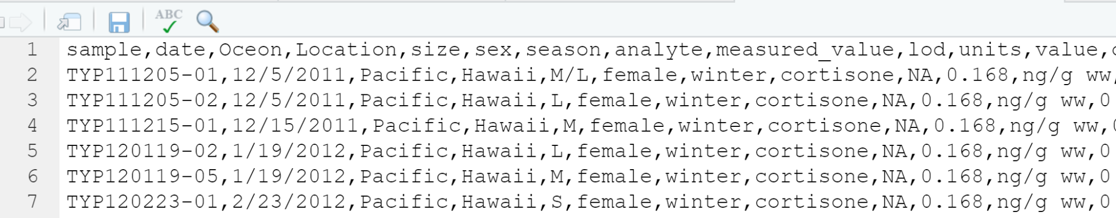

Figure2;
1=Spring; 2=Summer; 3=Fall; 4=Winter;
Scatter Plot of Female Progesterone in Different Seasons from Ref1
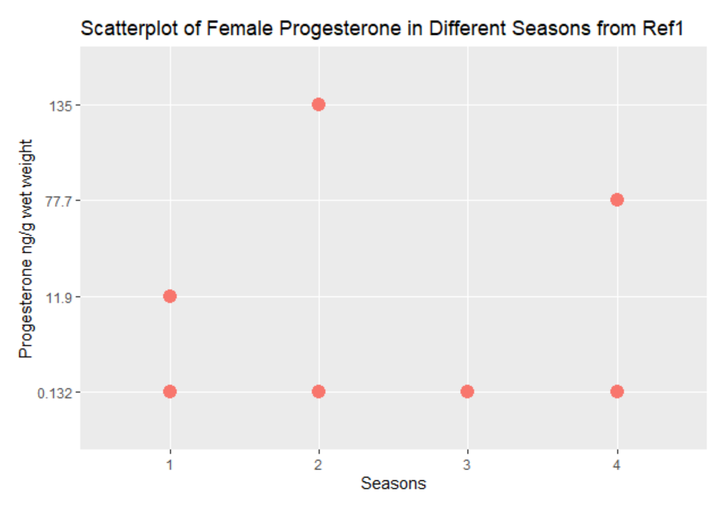

Figure3;
1=Spring; 2=Summer; 3=Fall; 4=Winter;
Scatter plot of Male Testosterone in Different Seasons from Ref1
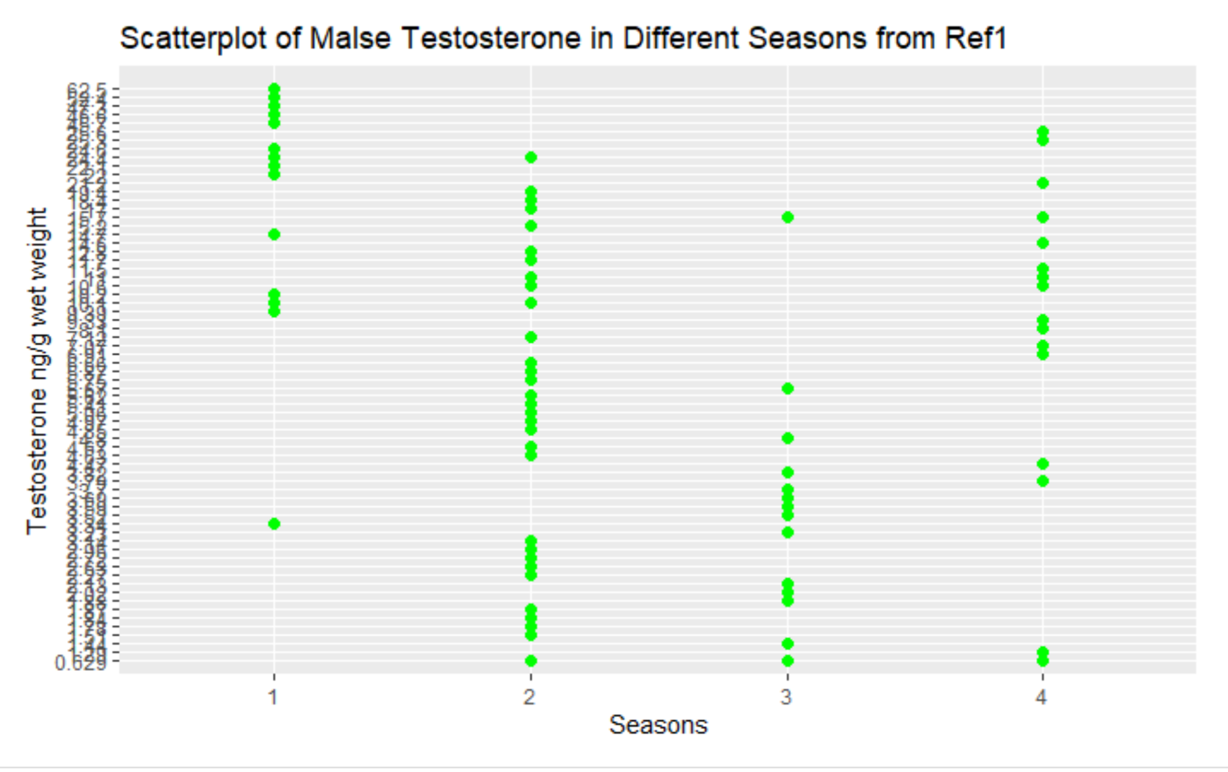
Figure4;
1=Spring; 2=Summer; 3=Fall; ( there is no data from winter)
Scatter Plot of Female Progesterone in Different Seasons from Ref7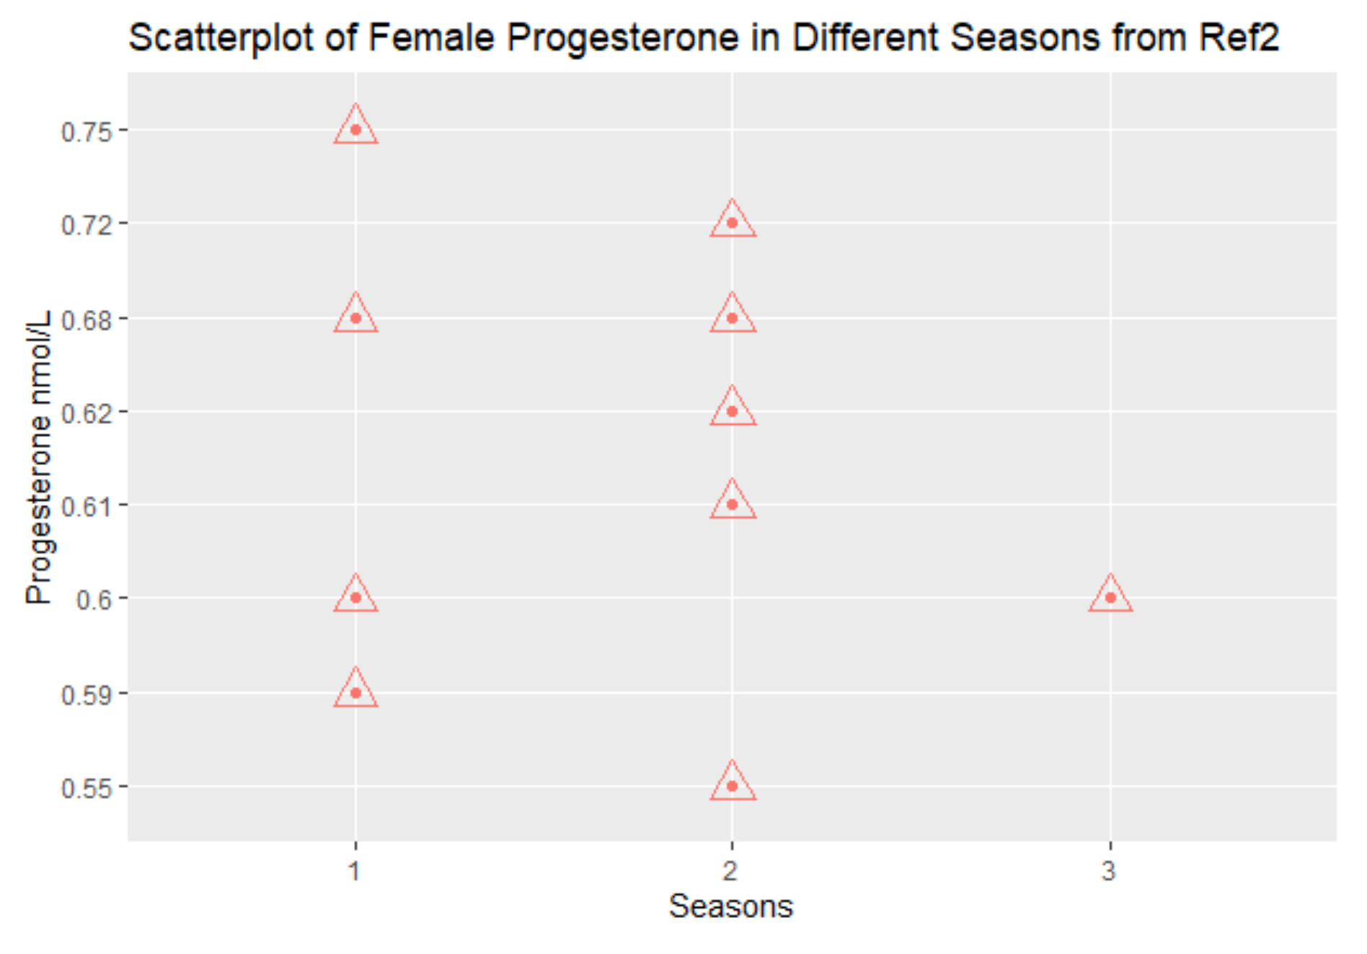

Figure5;
1=Spring; 2=Summer; 3=Fall; ( there is no data from winter)
Scatter Plot of Male Testosterone in Different Seasons from Ref7
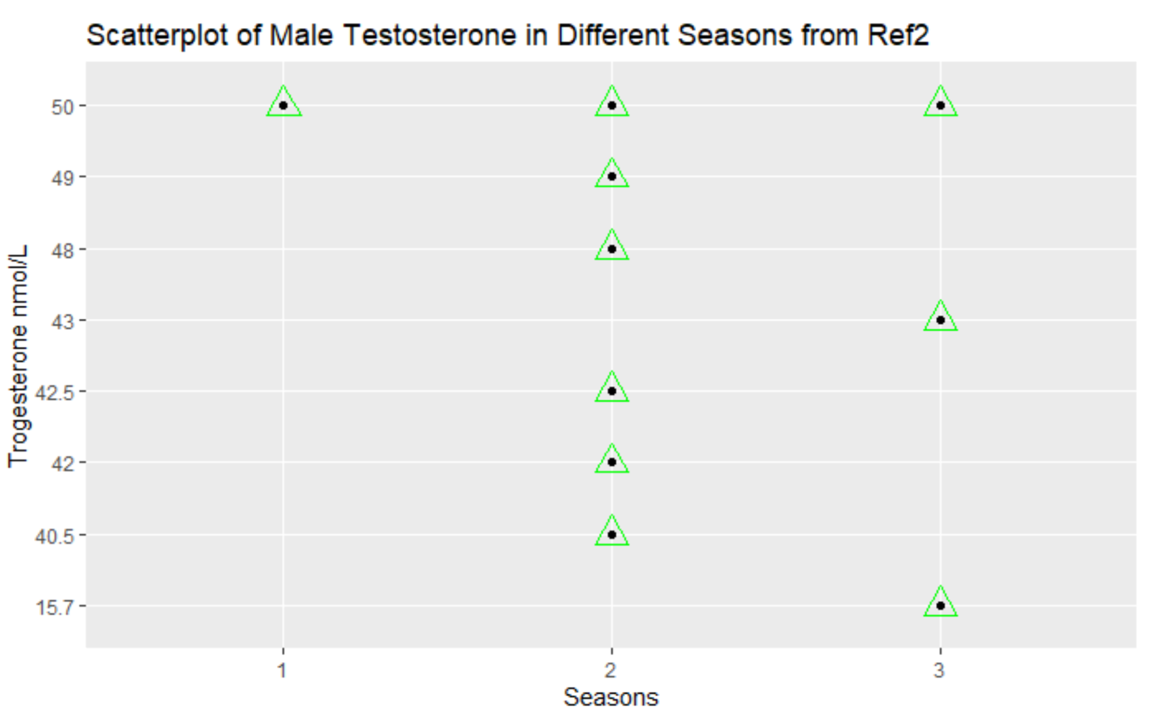
Figure6;
1=Spring; 2=Summer; 3=Fall; 4=Winter
Scatter plot of Male Testosterone in Different Seasons from Ref8
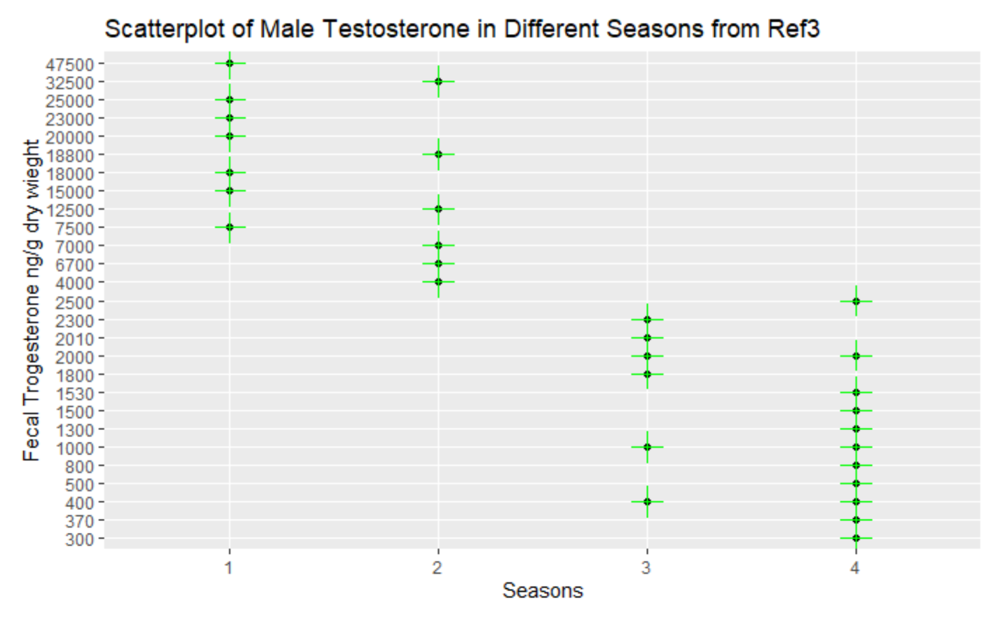
Figure7;
1=Spring; 2=Summer; 3=Fall; 4=Winter
Bar plot ofNumber Released in Different Seasons from Ref6
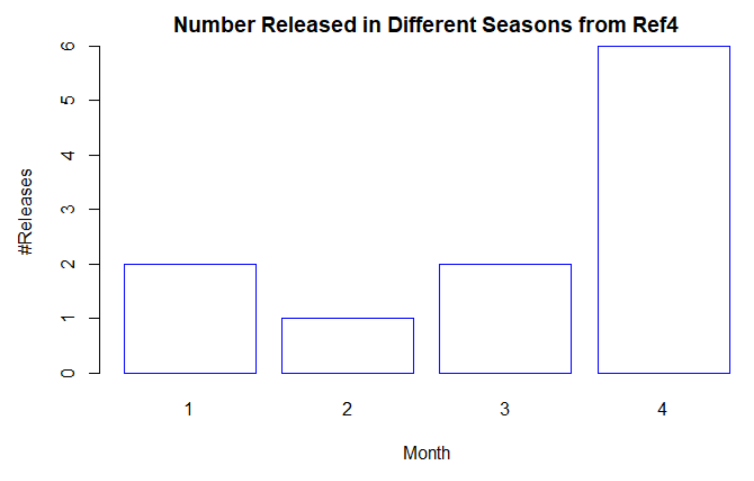
Figure8;
1=Spring; 2=Summer; 3=Fall; 4=Winter
Bar plot ofNumber Released in Different Seasons from Ref4
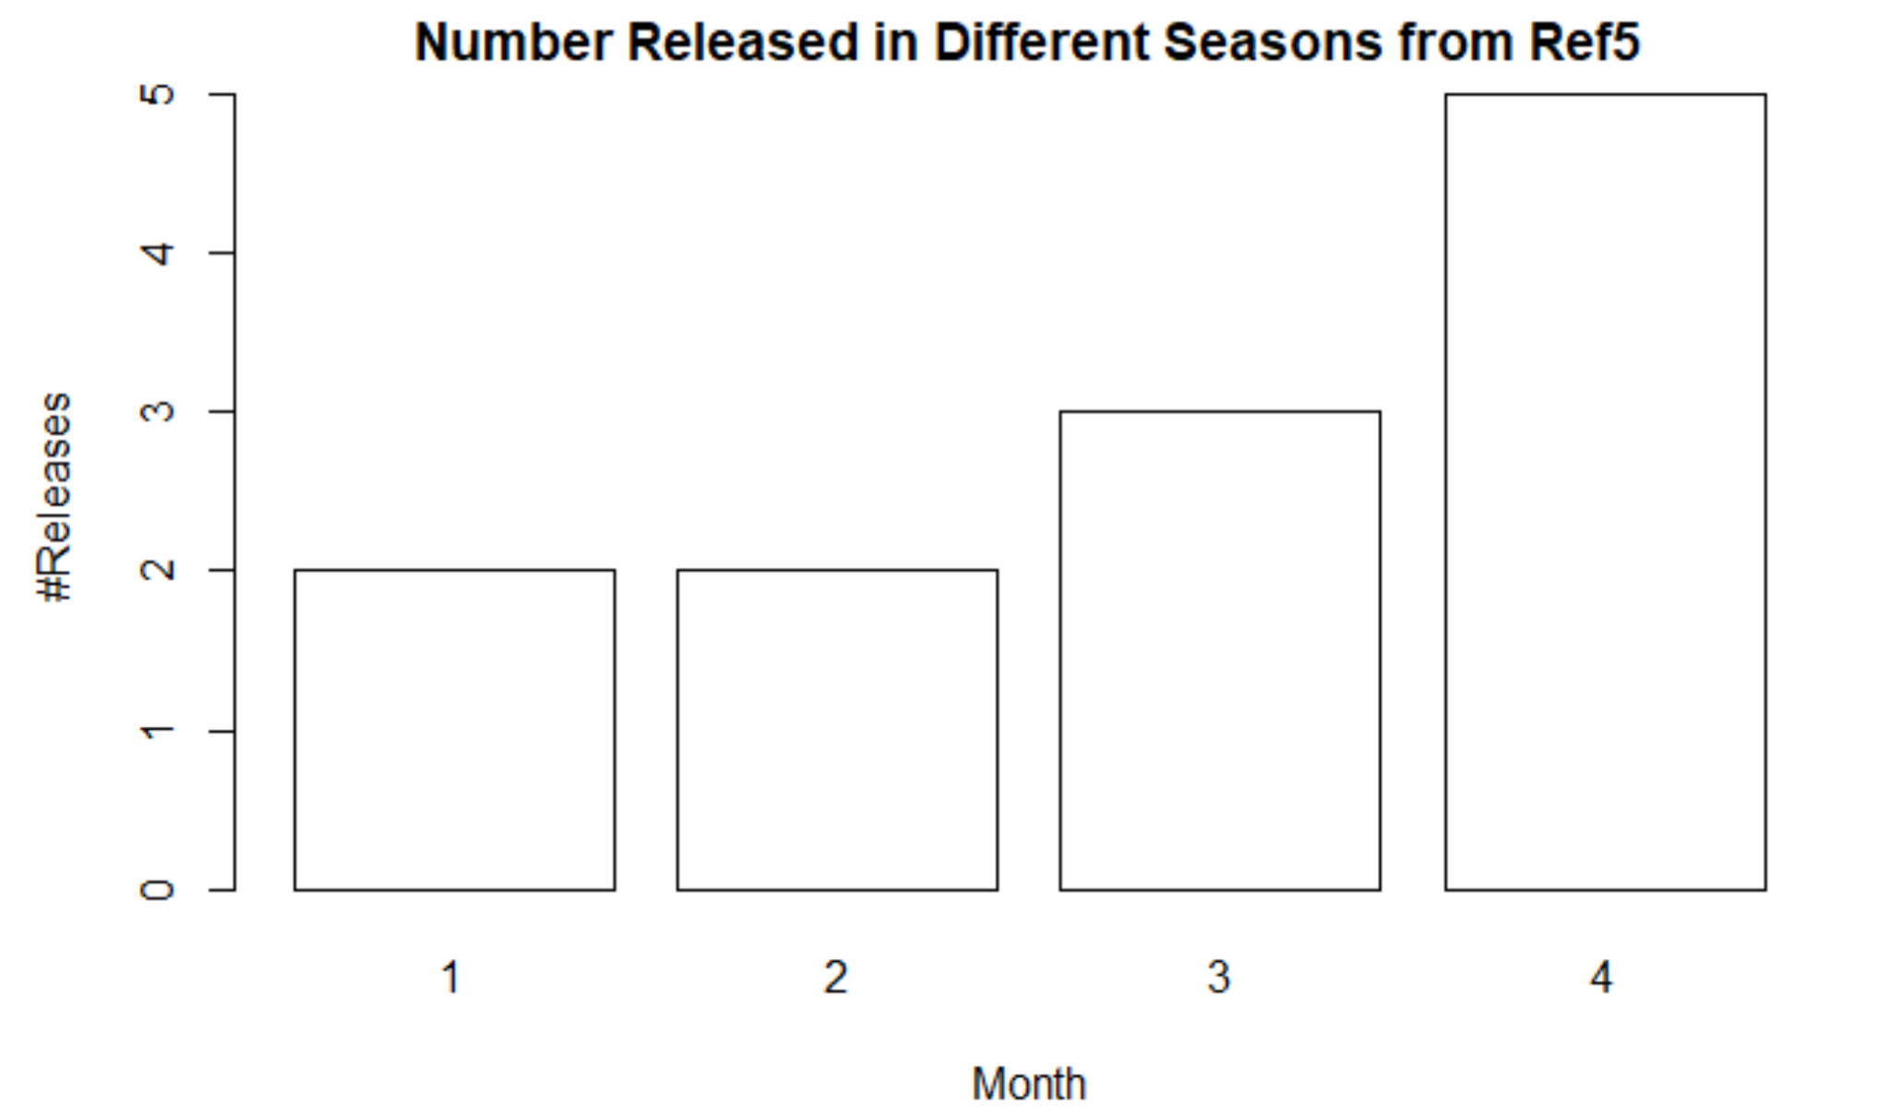
Figure9;
Link of CSV File of Raw Data and a Rmd File of Codes
https://github.com/Janet-liu2001/PSL379-raw-data-sheet

Table1
Correlation Table of Average Hormones Value and the Average Releasing Number
Correlation Table of Average Hormones Value and the Average Releasing Number
Degree of Freedom | 2
P-value | 0.223
Sample estimates Correlation | -0.777

